The laboratory work 2

Exercise 1: Accept two numbers from the user and calculate multiplication.

Exercise 2: Display “My Name Is James” as “My**Name**Is**James” using output formatting of a print() function.
Expected Output:
Use print() statement formatting to display the ** separator between each word.
For example: print('My', 'Name', 'Is', 'James') will display MyNameIsJames
So use one of the formatting argument of print() to turn the output into My**Name**Is**James

Exercise 3: Convert decimal number to octal using print() output formatting
Expected Output:
Display decimal number 8 as 10

Exercise 4: Write all content of a given file into a new file by skipping line number 5.
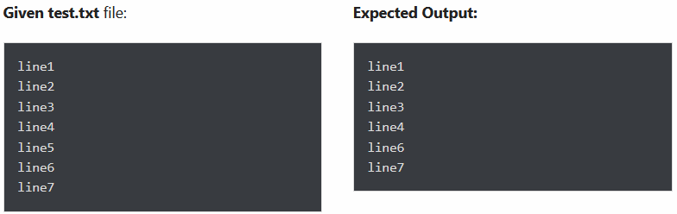

Exercise 5: Format the following data using a string.format() method.
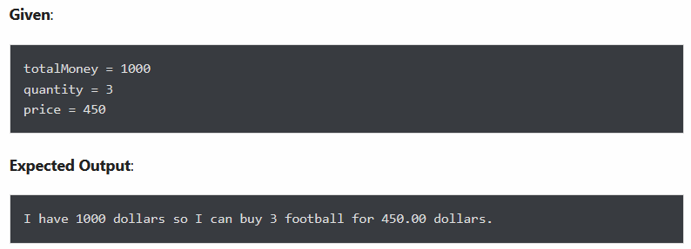

Exercise 6: Read line number 4 from the following file
